**JSP – Java Server Page**

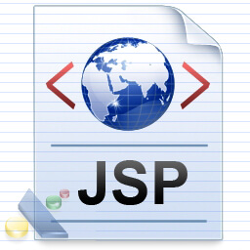

**JSP** technology is used to create web application just like Servlet technology. It can be thought of as an extension to Servlet because it provides more functionality than servlet such as expression language, JSTL, etc.

A JSP page consists of HTML tags and JSP tags. The JSP pages are easier to maintain than Servlet because we can separate designing and development. It provides some additional features such as Expression Language, Custom Tags, etc.

### The Lifecycle of a JSP Page

The JSP pages follow these phases:

* Translation of JSP Page
* Compilation of JSP Page
* Classloading (the classloader loads class file)
* Instantiation (Object of the Generated Servlet is created).
* Initialization ( the container invokes jspInit() method).
* Request processing ( the container invokes _jspService() method).
* Destroy ( the container invokes jspDestroy() method).

#### Note: jspInit(), _jspService() and jspDestroy() are the life cycle methods of JSP.

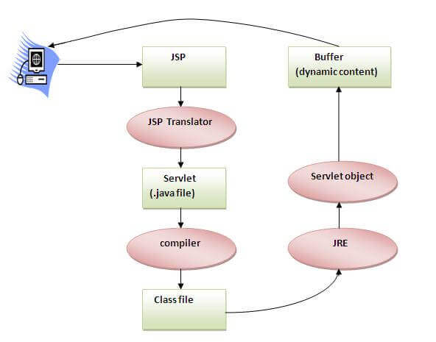

### Creating a simple JSP Page

To create the first JSP page, write some HTML code as given below, and save it by .jsp extension. We have saved this file as index.jsp. Put it in a folder and paste the folder in the web-apps directory in apache tomcat to run the JSP page.

**index.jsp**

Let's see the simple example of JSP where we are using the scriptlet tag to put Java code in the JSP page. We will learn scriptlet tag later.

1. <html>
2. <body>
3. <% out.print(2*5); %>
4. </body>
5. </html>

### How to run a simple JSP Page?

Follow the following steps to execute this JSP page:

* Start the server
* Put the JSP file in a folder and deploy on the server
* Visit the browser by the URL http://localhost:portno/contextRoot/jspfile, for example, http://localhost:8888/myapplication/index.jsp

### The Directory structure of JSP

The directory structure of JSP page is same as Servlet. We contain the JSP page outside the WEB-INF folder or in any directory.

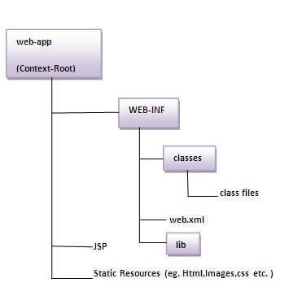

# Creating JSP in Eclipse IDE with Tomcat server

* Create a Dynamic web project
* create a jsp
* start tomcat server and deploy the project

### 1) Create the dynamic web project

For creating a dynamic web project click on File Menu -> New -> dynamic web project -> write your project name e.g. first -> Finish.

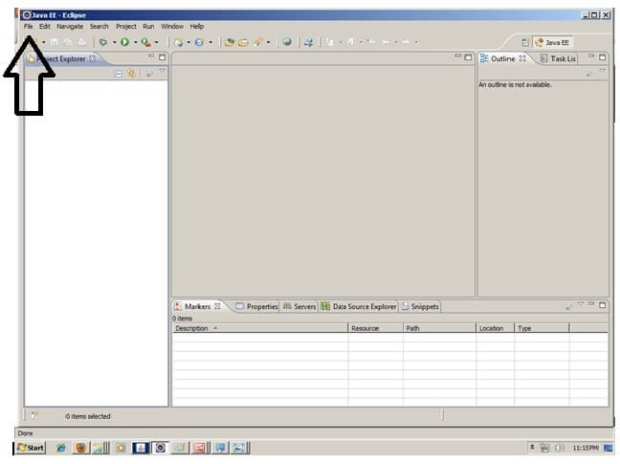

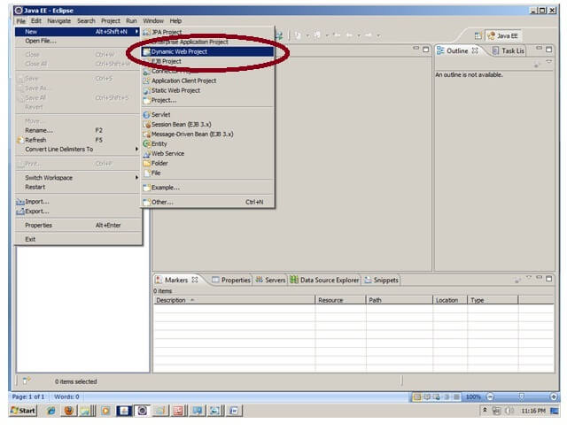

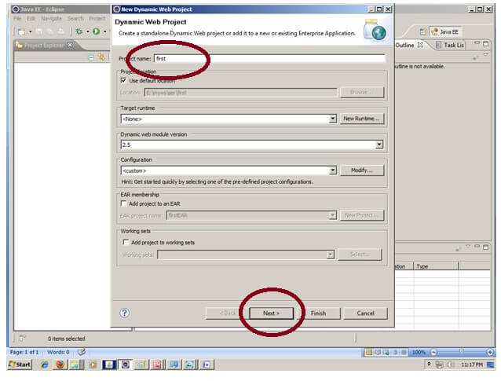

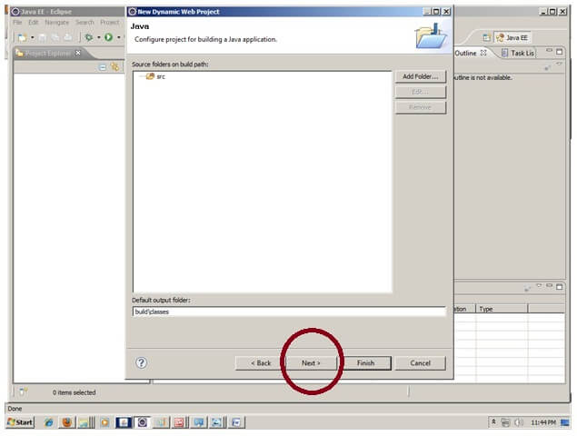

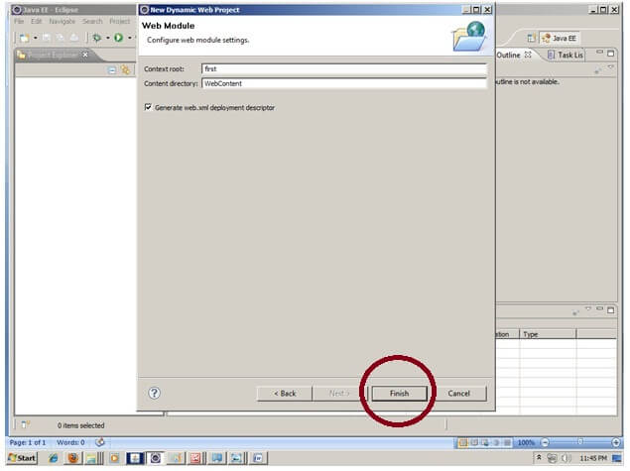

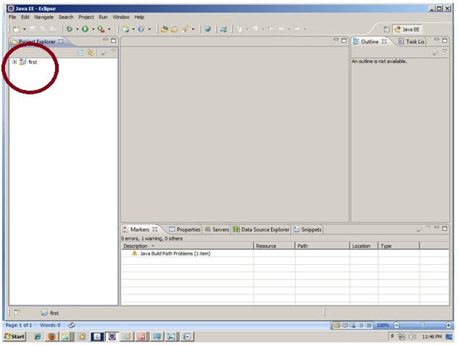

### 2) Create the JSP file in eclipse IDE

For creating a jsp file explore the project by clicking the + icon -> right click on WebContent -> New -> jsp -> write your jsp file name e.g. index -> next -> Finish.

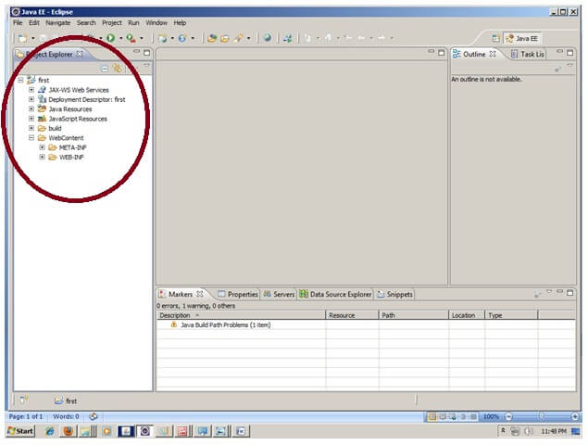

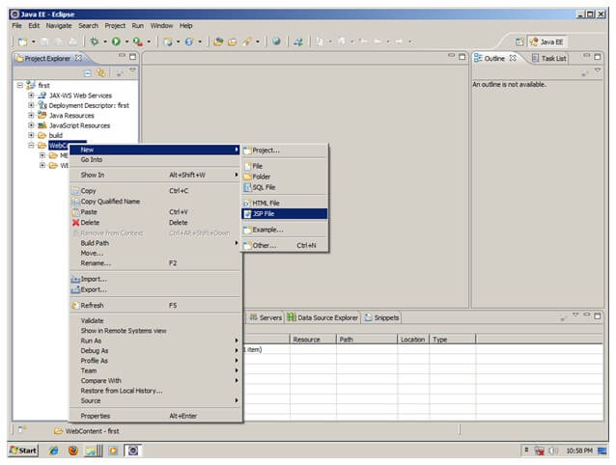

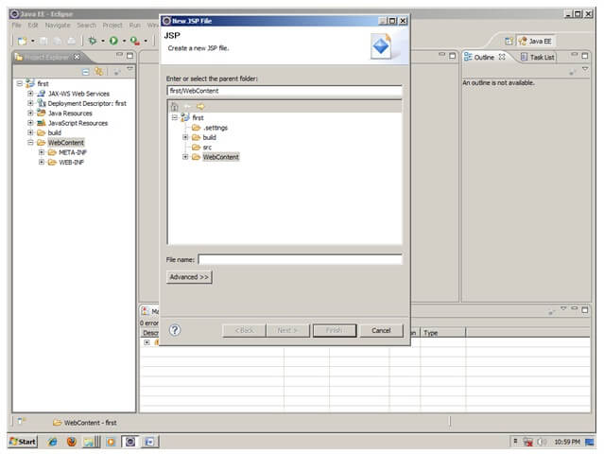

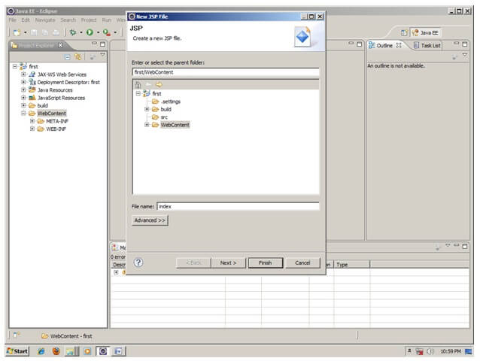

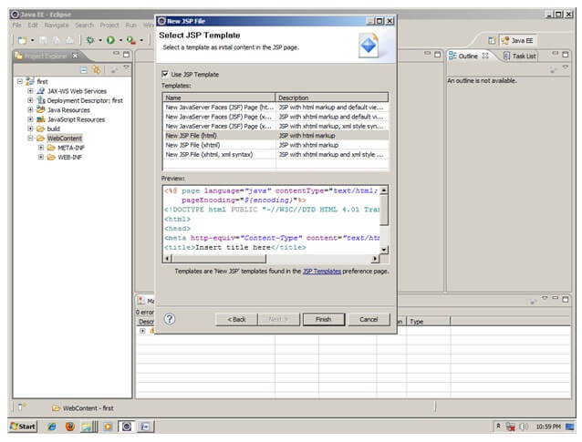

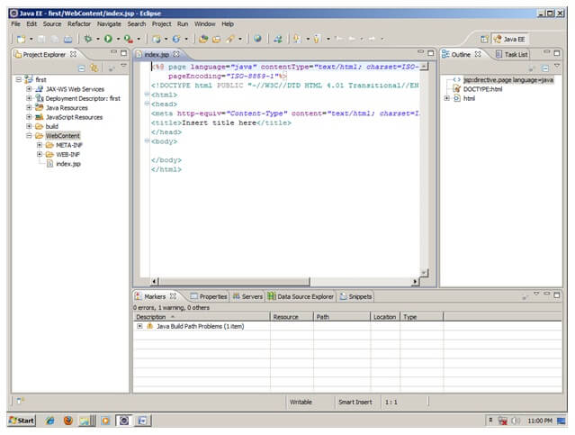

Now JSP file is created, let's write some code.

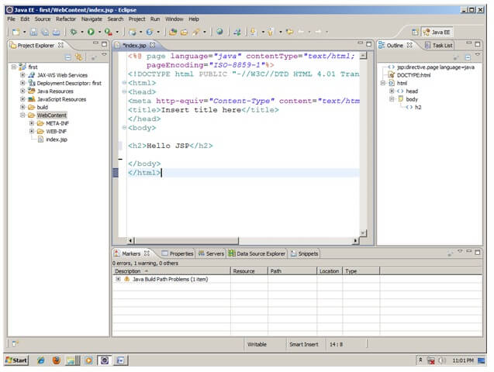

### 3) Start the server and deploy the project:

For starting the server and deploying the project in one step Right click on your project -> Run As -> Run on Server -> choose tomcat server -> next -> addAll -> finish.

If you are using Eclipse IDE first time, you need to configure the tomcat server First. Click for [How to configure tomcat server in eclipse IDE](https://www.javatpoint.com/how-to-configure-tomcat-server-in-eclipse-ide)

### Now start the tomcat server and deploy project

For starting the server and deploying the project in one step Right click on your project -> Run As -> Run on Server -> choose tomcat server -> next -> addAll -> finish.



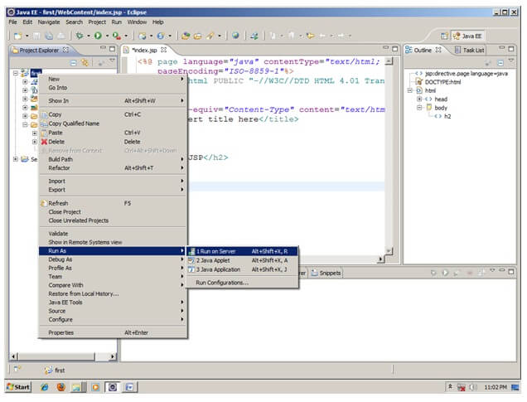

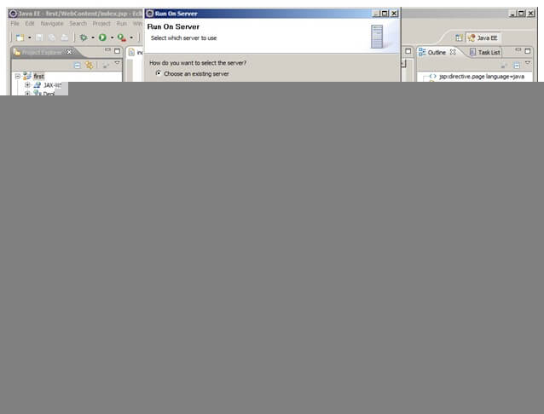

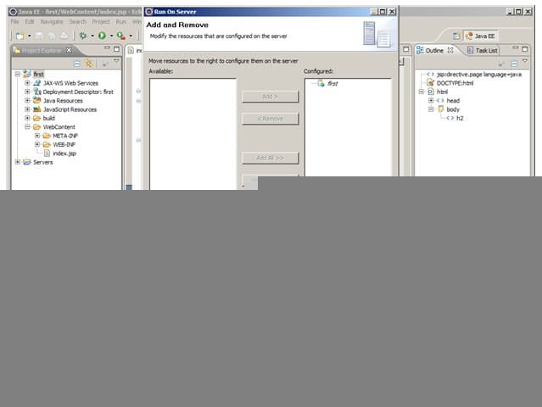

Yes, Let's see JSP is successfully running now.

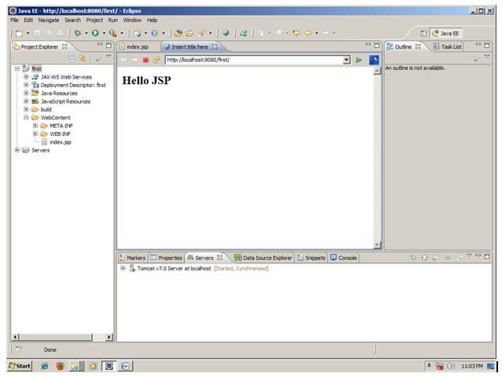

# JSP Scriptlet tag (Scripting elements)

In JSP, java code can be written inside the jsp page using the scriptlet tag. Let's see what are the scripting elements first.

## JSP Scripting elements

The scripting elements provides the ability to insert java code inside the jsp. There are three types of scripting elements:

* scriptlet tag
* expression tag
* declaration tag

### JSP scriptlet tag

A scriptlet tag is used to execute java source code in JSP. Syntax is as follows:

1. <%  java source code %>

### Example of JSP scriptlet tag

In this example, we are displaying a welcome message.

1. <html>
2. <body>
3. <% out.print("welcome to jsp"); %>
4. </body>
5. </html>

### Example of JSP scriptlet tag that prints the user name

In this example, we have created two files index.html and welcome.jsp. The index.html file gets the username from the user and the welcome.jsp file prints the username with the welcome message.

File: index.html

1. <html>
2. <body>
3. <form action="welcome.jsp">
4. <input type="text" name="uname">
5. <input type="submit" value="go"><br/>
6. </form>
7. </body>
8. </html>

File: welcome.jsp

1. <html>
2. <body>
3. <%
4. String name=request.getParameter("uname");
5. out.print("welcome "+name);
6. %>
7. </form>
8. </body>
9. </html>

# JSP expression tag

The code placed within **JSP expression tag** is written to the output stream of the response. So you need not write out.print() to write data. It is mainly used to print the values of variable or method.

### Syntax of JSP expression tag

1. <%=  statement %>

### Example of JSP expression tag

In this example of jsp expression tag, we are simply displaying a welcome message.

1. <html>
2. <body>
3. <%= "welcome to jsp" %>
4. </body>
5. </html>

#### Note: Do not end your statement with semicolon in case of expression tag.

### Example of JSP expression tag that prints current time

To display the current time, we have used the getTime() method of Calendar class. The getTime() is an instance method of Calendar class, so we have called it after getting the instance of Calendar class by the getInstance() method.

index.jsp

1. <html>
2. <body>
3. Current Time: <%= java.util.Calendar.getInstance().getTime() %>
4. </body>
5. </html>

### Example of JSP expression tag that prints the user name

In this example, we are printing the username using the expression tag. The index.html file gets the username and sends the request to the welcome.jsp file, which displays the username.

File: index.jsp

1. <html>
2. <body>
3. <form action="welcome.jsp">
4. <input type="text" name="uname"><br/>
5. <input type="submit" value="go">
6. </form>
7. </body>
8. </html>

File: welcome.jsp

1. <html>
2. <body>
3. <%= "Welcome "+request.getParameter("uname") %>
4. </body>
5. </html>

# JSP Declaration Tag

1. [JSP declaration tag](https://www.javatpoint.com/jsp-declaration-tag)
2. [Difference between JSP scriptlet tag and JSP declaration tag](https://www.javatpoint.com/jsp-declaration-tag#diff)
3. [Example of JSP declaration tag that declares field](https://www.javatpoint.com/jsp-declaration-tag#declarationex1)
4. [Example of JSP declaration tag that declares method](https://www.javatpoint.com/jsp-declaration-tag#declarationex2)

The **JSP declaration tag** is used to declare fields and methods.

The code written inside the jsp declaration tag is placed outside the service() method of auto generated servlet.

So it doesn't get memory at each request.

#### Syntax of JSP declaration tag

The syntax of the declaration tag is as follows:

1. <%!  field or method declaration %>

### Difference between JSP Scriptlet tag and Declaration tag

|  |  |
| --- | --- |
| **Jsp Scriptlet Tag** | **Jsp Declaration Tag** |
| The jsp scriptlet tag can only declare variables not methods. | The jsp declaration tag can declare variables as well as methods. |
| The declaration of scriptlet tag is placed inside the _jspService() method. | The declaration of jsp declaration tag is placed outside the _jspService() method. |

### Example of JSP declaration tag that declares field

In this example of JSP declaration tag, we are declaring the field and printing the value of the declared field using the jsp expression tag.

### index.jsp

1. <html>
2. <body>
3. <%! int data=50; %>
4. <%= "Value of the variable is:"+data %>
5. </body>
6. </html>

### Example of JSP declaration tag that declares method

In this example of JSP declaration tag, we are defining the method which returns the cube of given number and calling this method from the jsp expression tag. But we can also use jsp scriptlet tag to call the declared method.

### index.jsp

1. <html>
2. <body>
3. <%!
4. int cube(int n){
5. return n*n*n*;
6. }
7. %>
8. <%= "Cube of 3 is:"+cube(3) %>
9. </body>
10. </html>